Level 5 -> Level 6

The goal of this level is to find out the file which is human readable, 1033 bytes in size, not executable in the **inhere** directory and get the password of next level.

So now, firstly we will check the files and folders of the current directory in which we are by using **ls** command. Simple **ls** command is used to list out all the files and folder of the directory in which the user is present. A directory named **inhere** is present in the current directory in which we are. We will jump into this directory using **cd** command.

Again, using ls command, we will check files and directories present in inhere directory. We found 20 different directories and it will be difficult for us to check each file in each directory to find required file.

**du** command short for disk usage, is used to estimate file space usage. We can find the size of each and every file using **du -ab** command. But again, it is difficult for us to find the file of size 1033 bytes in all these files.

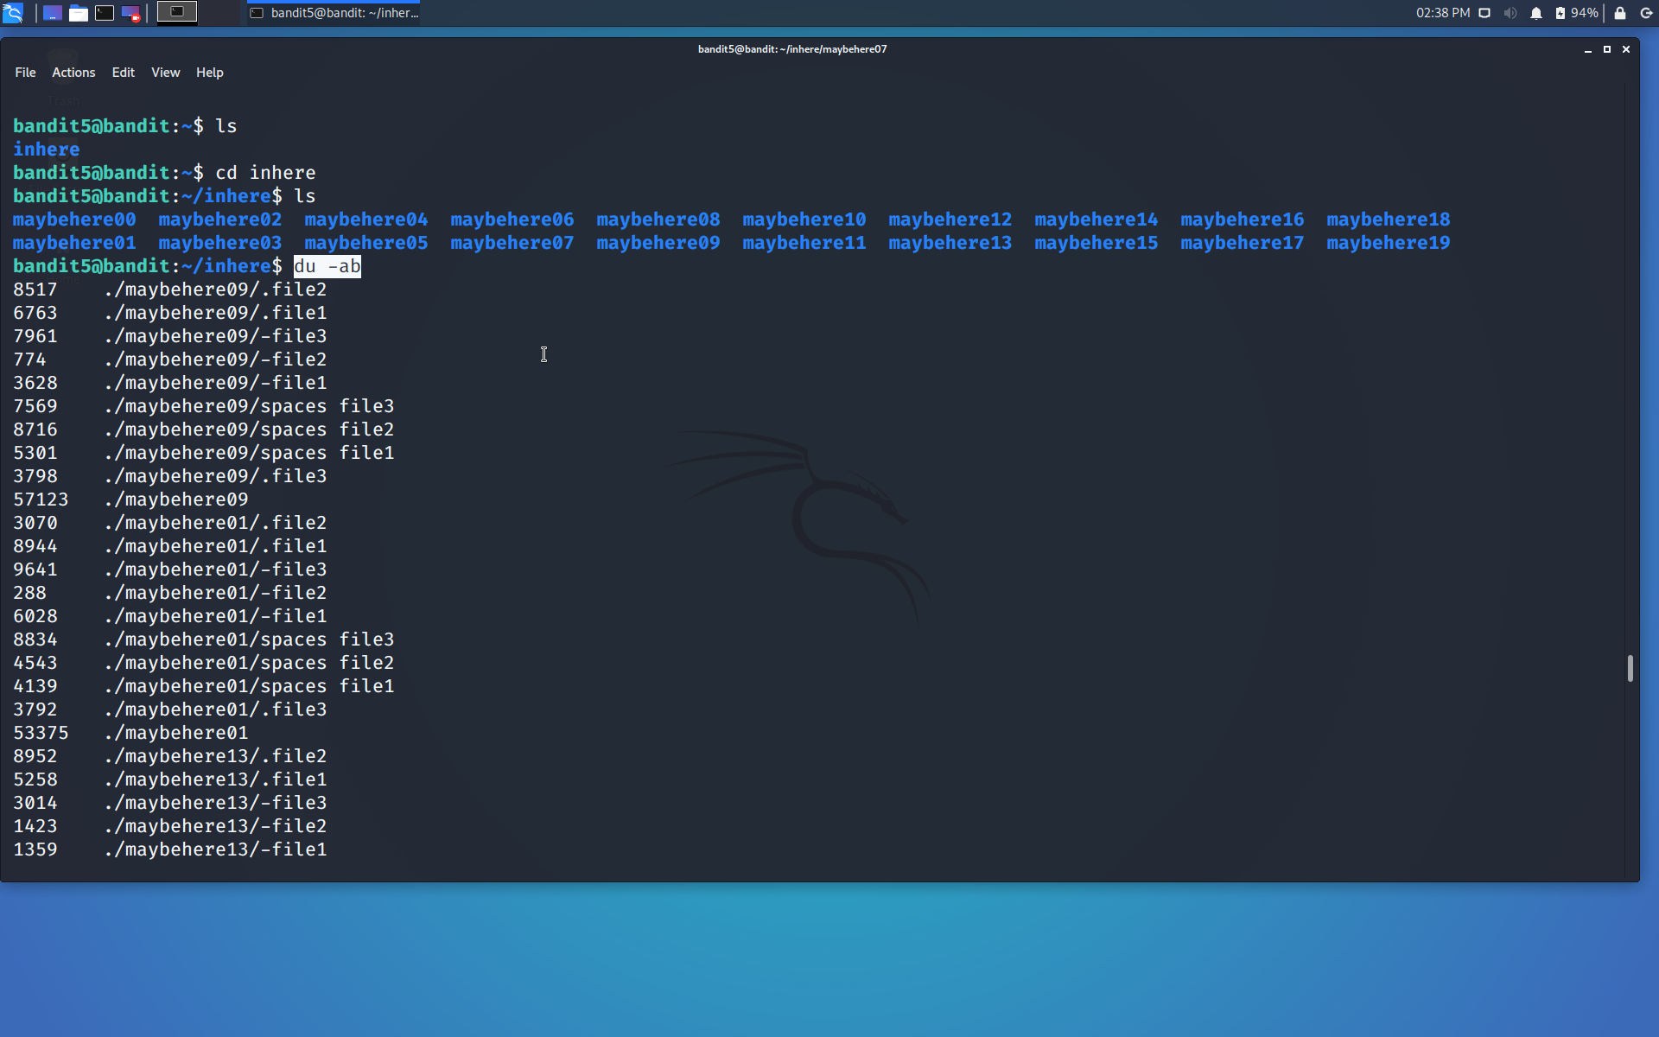

We need the file of size 1033 bytes so we can use **file ./ -size 1033c** command. **./** is used to access all the files of each and every directory and **c** is used for size in bytes. This command will display only that file which has size 1033 bytes.

After running the command we found that the required file is in **maybehere07** directory and the file name is **.file2 ,** we will jump into the maybehere07 directory using **cd** command and then read the content of file using simple **cat** command.

We got the password…

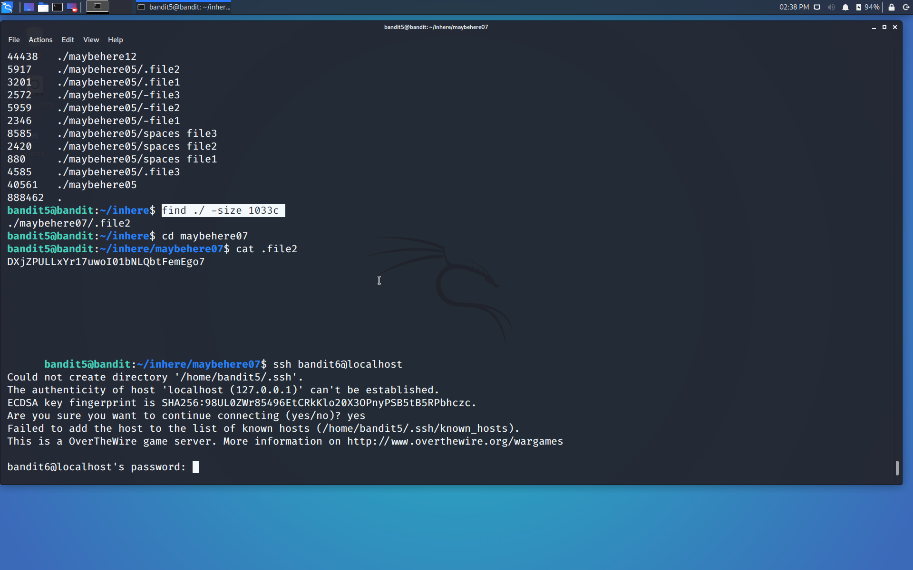

Use the command **ssh bandit6@localhost** to connect to the level 6.

Enter the password and hit enter.

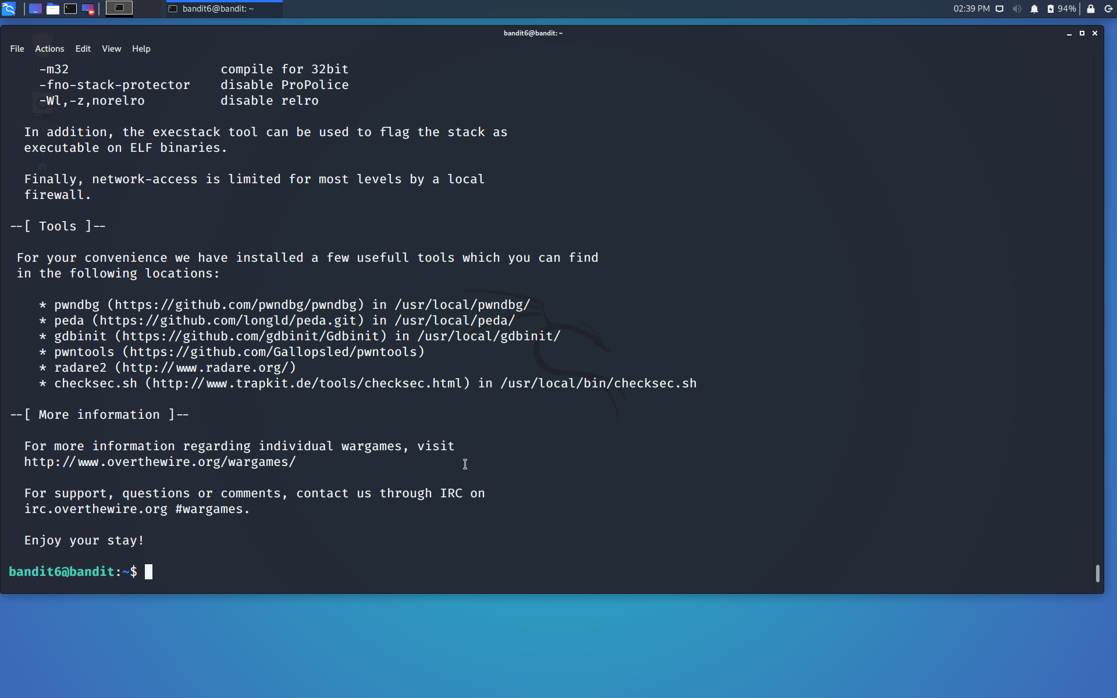

Successfully passed level 6.…